RESOLUTION NO.__________

RE: CERTIFICATE OF APPROPRIATENESS UNDER THE
PROVISIONS OF THE ACT OF THE PENNSYLVANIA
LEGISLATURE 1961, JUNE 13, P.L. 282 (53
SECTION 8004) AND BETHLEHEM ORDINANCE NO.
3952 AS AMENDED.

WHEREAS, it is proposed to install a new awning with signage at 129 W. Fourth Street.

NOW, THEREFORE, BE IT RESOLVED by the Council of the City of Bethlehem that a Certificate of Appropriateness is hereby granted for the work.

Sponsored by: (s)

(s)

ADOPTED BY COUNCIL THIS DAY OF

(s)
President of Council

ATTEST:

(s)
City Clerk

HISTORIC CONSERVATION COMMISSION

CASE # 605– It is proposed to install a new awning with signage at 129 W. Fourth Street
OWNER/APPLICANT: Joe Hanna/ Mustafa Okumus

The Commission upon motion by Mr. Roeder seconded by Ms. Starbuck adopted the proposal that City Council issue a Certificate of Appropriateness for the proposed work described herein:
- The proposal to install a new awning with a sign at 129 W. Fourth Street was represented by Mustafa Okumus.

- The new awning will be approximately 25’ w x 40” h x 30” d with 1”x1”x1/8” thick walled steel tubing supports. The awning will not extend over the side pilasters and the awning will not be over the apartment entrance.
- The 18 oz. canvas fabric will be dark forest green, and the awning will have open ends. The awning will be 10’ above the sidewalk to meet code.
- The awning sign will read “NY City Village Pizza” in off-white 6” serif style lettering on the 8” valance.
- The attachment of the awning support pipes will only go into mullions between leaded glass and at either end. It must go over moldings and not cut into moldings.

- The motion to approve the proposal was unanimously approved.

CU: cu
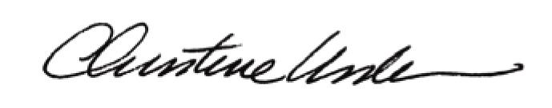

By:

Date of Meeting: January 23, 2017 Title: Historic Officer

